Reading Isaiah Bible Study, Week 7:
The present crisis (735 b.c.) in light of the future King of Peace

740 b.c.  ch. 6 | Uzziah | Isaiah was commissioned to preach to a hardened people in the year Uzziah died. This would last until the land was laid waste in 701.
 | Jotham | Prosperity and peace ended with Jotham.
735 b.c.  ch. 7-12 | Ahaz | Ahaz was threatened by Israel and Aram because of pro-Assyrian policies. On the verge of warfare, Isaiah promised rescue, which quickly arrived.
701 b.c.  ch. 13-39 | Hezekiah | Hezekiah joined the Babylonians and Egyptians in revolting against Assyria. The Assyrians laid waste most of Judah and besieged Jerusalem, but the LORD miraculously spared Jerusalem from capture.

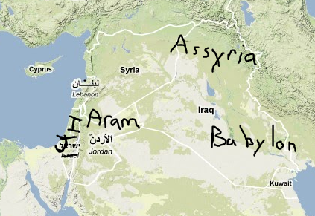
Introductory questions:
1. What are modern Americans prone to "fear and dread" in place of the LORD?

Isaiah 8: Prepare for invasion!
2. Review 8:1-15 from last time. What are the main points of the prophecy?
3. 8:16-18. What is Isaiah's response to the coming crisis?
4. What about disciples? See Isa 50:4 and Isa 54:13. On writing: Isa 29:11-12 and Isa 30:8-11. 2 Kings 2:5-12. Why doesn't the Bible give us more detail about the schools of the prophets?
5. How does Hebrews 2:13 affect our interpretation?
6. Why would 8:19-22 be apt advice when the land was under threat of invasion?
Look at 8:20 in the NIV (2010 update):
Consult God’s instruction and the testimony of warning. If anyone does not speak according to this word, they have no light of dawn.
What is the difference between this and the old NIV? Cp Isaiah 1:10 in the new NIV:
Hear the word of the LORD, you rulers of Sodom; listen to the instruction of our God, you people of Gomorrah!
Isaiah 9:1-7: Distant peace, distant king, but immediate wrath
1. Isa 9:1-5. What is going to happen in Galilee? Why is Galilee singled out?
2. See Judges 6:35, 7:22-25 for Gideon's defeat of Midian.
3. Compare 4:13-17. How does Matthew use this passage?
4. Isa 9:6-7. What could the people tell about the Messiah if they studied this prophecy?
5. How did Jesus fulfill this prophecy?
6. Why didn't the people of Judah expect Jesus or recognize him when he came?
Overview :
Isaiah 9:8-12. What happened, and what does Isaiah say will happen?
Isaiah 9:13-17. What has caused the LORD's anger, and what will be the punishment?
Isaiah 9:18-21. Which elements of this passage are literal, and which are metaphorical?
Isaiah 10:1-4. Where have we seen this charge before? (Isa 1:23-24, 3:14-15, ch. 5)
Final discussion: As Christians in 2011, what do we take away from these verses?

