Reading Isaiah Bible Study, Week 5:
Isaiah's call to the ministry (ch. 6) and first political crisis (ch. 7)

740 b.c.  ch. 6 | Uzziah | Isaiah was commissioned to preach to a hardened people in the year Uzziah died.
 | Jotham | Prosperity and peace ended with Jotham.
735 b.c.  ch. 7 | Ahaz | Ahaz was threatened by his neighbors for being pro-Assyrian. On the verge of serious warfare, Isaiah promised deliverance, which arrived suddenly.
701 b.c. | Hezekiah | Hezekiah joined the Babylonians and Egyptians in revolting against Assyria. The Assyrians destroyed most of Judah and besieged Jerusalem. Isaiah was again involved, first in rebuking the king and people, and then in promising salvation.
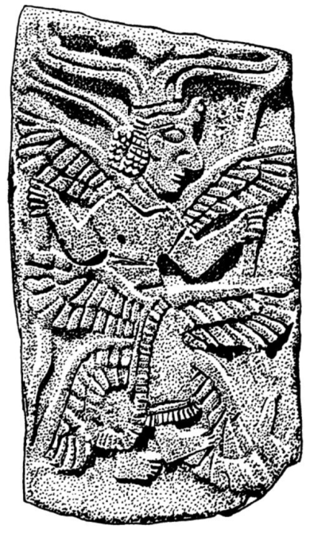
Introductory questions:
1. What, if anything, is considered holy to modern Americans?
2. What does it mean to be holy?

Isaiah 6: A Vision and Commission
3. As we read and consider this section of Scripture, in the back of your mind consider the question: what is the main point of this passage?
4. List the details of Isaiah's vision, and what each of those details tell us about the LORD.
5. What was Isaiah's message to the people?
6. How did Isaiah respond to his commission?
This piece of limestone is about 70 cm high; it originally was part of a wall decoration of the palace in the North-Syrian Tell Halaf. The stone relief shows a six-winged figure.
7. How long was Isaiah to preach this message?
Cf. Isaiah 32:1-8.
8. Look at Matthew 13:11-16. How is this passage used there?
9. The phrase "the Holy One of Israel" is used 30 times in the Bible. 25 of those are in Isaiah. It can be used both as a name of terror (Isa 5:24, 30:12) and consolation (Isa 48:17; Isa 55:5).
10. Why is it essential as Christians to recognize God's holiness?

11. What application can we make of Isaiah's commissioning to our own? What are the similarities and dissimilarities?
Isaiah 7: The First Crisis, the Great Sign

1. Read 7:1-9. How does God want Ahaz to respond to the threat of invasion?

2. In 722 B.C., the Assyrians exiled the people of Samaria. In 670 B.C. the Assyrians imported other nationalities to re-settle the region. What prophecy from our section does this fulfill?

2. Read 7:10-14. What is so wicked about Ahaz's choice?

3. The word translated "virgin" means "young unmarried girl" and by implication refers to a virgin. However, some critics of Christianity will argue that this is not referring to the virgin birth, since the word used here is not the normal word for virgin. Their argument is not very strong, but you might come across it on TV or somewhere.

4. Read 7:14-17 verse by verse. What is he predicting?

5. Read 7:18-25: This gives detail about the Assyrian invasion. What does he say will happen to the land?

6. Looking back over verses 13-25, at what point does Isaiah's quotation to Ahaz end, and a new section begin?

7. What is the effect of having such an important Messianic prophecy given at this critical time in the history of Israel?

Chapter 8: Immanuel in trouble

1. Read 8:1-4. What is Isaiah doing?

2. How is this related to the Immanuel mentioned in chapter 7? What is the same, and what is different?

3. Read 8:5-6. What does God declare about the people of Judah?

4. What is unexpected about 8:9-10.

5. Looking back over chapters 6-8, what did Isaiah expect to live through in the course of his ministry?

