Reading Isaiah Bible Study, Lesson 2: Isaiah 1-2 as guide to the rest of the book

Introductory question: If God was to send a prophet to the church today, what message do you think he would bring?

Isaiah 1:1–9, An Indictment and Lament

1. Read v. 1 and review: Which kings were good, and which were bad?

740 b.c. | Uzziah | Isaiah was commissioned to preach in the year Uzziah died. He was told that the people would reject his message until the land was laid waste.
 | Jotham | Prosperity and peace for Judah ended with Jotham.
735 b.c. | Ahaz | Ahaz was threatened by his neighbors for being pro-Assyrian. On the verge of serious warfare, Isaiah promised deliverance, which arrived suddenly.
701 b.c. | Hezekiah | Hezekiah joined the Babylonians and Egyptians in revolt against Assyria. The Assyrians destroyed most of Judah and besieged Jerusalem. Isaiah rebuked foreign alliances, but then promised salvation when they repented.

2. Read. v. 2. Why are the heavens and earth mentioned? Compare Dt 30:15-21 and Dt 31:27-29.

3. Read v. 3. What is the relationship between the first and second line? This movement is called parallelism, and very common in the Bible. It often goes unnoticed, but recognizing it can enhance our appreciation of Biblical poetry, and occasionally help clarify an obscure verse.

4. Read v. 4–9. What is the message? When does it seem to have been written?

Isaiah 1:10–17, The Word of the LORD to the rulers and people

5. What does the LORD say about the people's worship, and why?

6. How can the leaders and people once again have their prayers answered?

7. How do we apply this type of section to ourselves today?

Isaiah 1:18–20, Brief message of repentance and forgiveness

1. What is the LORD's message to his rebellious people?

2. Compared to the previously considered section, how do we apply this to ourselves today?

Isaiah 1:21–31, The past and future of Zion
3. V. 21–28, what is the problem described, and how will it be solved?

4. Compare v. 21 and 26. What literary device do you notice?

5. Read. v. 29–31. This is the first of many references to pagan worship we will encounter.
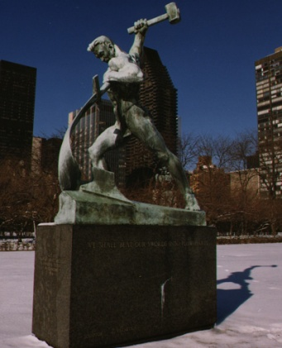
6. How can we apply this passage to our lives today?

Isaiah 2:1–5, Zion in the last days

7. From Isaiah's perspective, what does he see? (if time, cp. Micah 5)

8. What is the fulfillment of this prophecy?
"Let Us Beat Swords into Plowshares" a gift to the UN from the Soviet Union in 1959.

Isaiah 2:6–22, Condemnation of pride

9. This section contains a lot of repetition, in a style unique to the book of Isaiah. Have someone read the entire section, and consider just listening instead of reading along.

10. What types of pride are condemned in this section?

11. V. 22, thematically, is one of the key verses in the book. How have the Judahites trusted in man? After considering that, how do we often trust in man rather than God?

Final consideration: How do the chapters considered today form a fitting introduction to Isaiah?

