Bible Study, 27 October 2018
Questions from the ark story
1. Clean and Unclean animals in the flood.
- Genesis 7:1-3
vv. 2-3 literally, “You shall take with you of every clean animal seven seven, a male and his female; and of the animals that are not clean two, a male and his female; also of the birds of the sky, seven seven, male and female, to keep offspring alive on the face of all the earth.”
- Leviticus 11 and Deuteronomy 14. Leviticus 4:12 and 5:2ff.
2. Were animals vegetarians before the flood?
- Genesis 3:21 and 4:4.

Noah’s failure
A. Genesis 9:18-23
- How could this happen?
- Is there any indication that Ham’s behavior was inappropriate?
- What was appropriate about Shem and Japheth’s reaction?
- Can we take any lessons from regarding:
  - Our own temptations to fall into sin like Noah?
  - The way we deal with others who have fallen into sin?
B. Genesis 9:24-29
- What are the different ways of understanding this verse? Is there a way to see Noah as righteous in this action, or is this a hung-over continuation of his sin?
- Are verses 26-27 related to this incident, or are they something else? Where else in Genesis do we see blessings and curses of someone’s descendants?
- Why would it be wrong to connect this to slavery in the United States, as was done in the southern US before the Civil War?
C. Genesis 10
1. Skim this chapter and see if anything strikes you as interesting. Do you recognize any of the peoples? Do you wish you knew more about anything?

D. Genesis 11:10-31
1. Skim this and note what happens with people’s ages. Also see the next page. What do you think is happening?

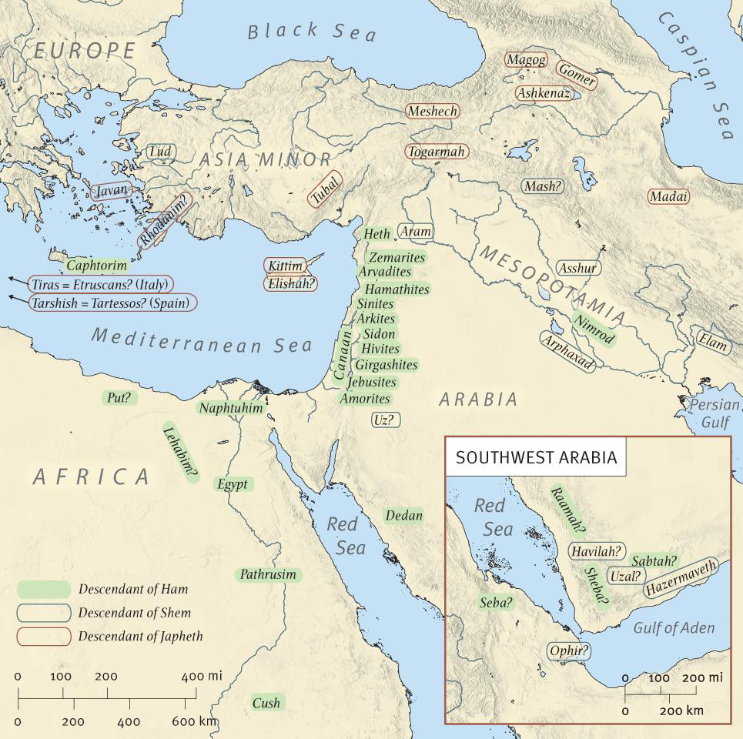

The nations of
Genesis 11

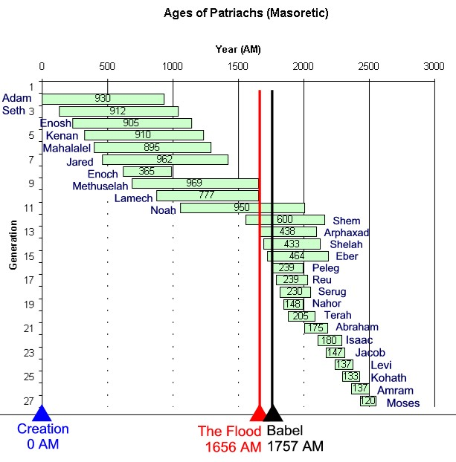
Masoretic:
Hebrew text
(the Greek text
Has different
Numbers)

