Bible study:
Interesting (and debatable) Luther quotes:
On Adam’s translation to immortality: “For us today it is amazing that there could be a physical life without death and without all the incidentals of death, such as diseases, smallpox, stinking accumulations of fluids in the body, etc. In the state of innocence no part of the body was filthy. There was no stench in excrement, nor were there other execrable things. Everything was most beautiful, without any offense to the organs of sense; and yet there was physical life. Adam ate, he masticated, he digested; and if he had remained as he was, he would have done the other things physical life demands until at last he would have been translated to the spiritual and eternal life.
This, too, we have lost through sin, because now the present life is separated from the future life by that awful intermediate event, death. In the state of innocence that intermediate event would have been a most delightful one; by it Adam would have been translated to the spiritual life or, as Christ calls it in the Gospel, to the angelic life (Matt. 22:30), in which physical activities come to an end. For in the resurrection of the dead we shall not eat, drink, or marry. This present physical state would have come to an end, and the spiritual life would have followed, just as we also believe that it will follow, thanks to Christ. Adam would have been divested of the glory which befitted a child and invested with heavenly glory; he would have been divested of his lower activities, which nevertheless would have been pure and not burdensome, as they are now after the Fall. And from the innocence of a child, so to speak, he would have been translated into the virile innocence which the angels have and which we, too, shall have in the future life.”
On Genesis 2:20: “What an ocean of knowledge and wisdom there was in this one human being! Moreover, although Adam lost much of this knowledge through sin, I nevertheless believe that everything still to be found in the books of all the wise men who have written for the many centuries since scientific pursuits had their first beginning could not equal that wisdom which still remained in Adam later on but gradually became fainter in his descendants and has almost been blotted out.”
Here's kind of a weird one on marriage and sex before the fall: “If Adam had persisted in the state of innocence, this intimate relationship of husband and wife would have been most delightful. The very work of procreation also would have been most sacred and would have been held in esteem. There would not have been that shame stemming from sin which there is now, when parents are compelled to hide in darkness to do this. No less respectability would have attached to cohabitation than there is to sleeping, eating, or drinking with one’s wife.”
The serpent’s identity:
2 Corinthians 11:3: But I am afraid that just as Eve was deceived by the serpent’s cunning, your minds may somehow be led astray from your sincere and pure devotion to Christ.
2 Corinthians 11:14: And no wonder, for Satan himself masquerades as an angel of light.
Revelation 12:9: The great dragon was hurled down—that ancient serpent called the devil, or Satan, who leads the whole world astray. He was hurled to the earth, and his angels with him.

Possible location of the garden of Eden:
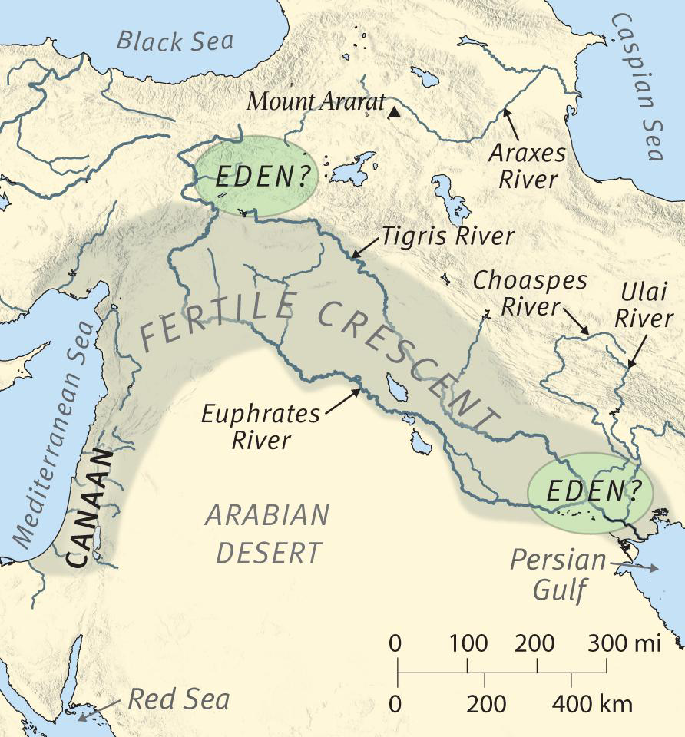

DISCUSSION AND GROUP ACTIVITY:
- Is the modern scientific community dispassionate in its search for truth, or biased against traditional Christianity?
- Why do so many evangelicals now embrace evolution?
- Agree or disagree true science will never discover anything that contradicts the Bible.
- Is there compelling physical evidence for a young earth that they don’t tell you about in science class?
Group activity: check out an article from one of the following websites and be prepared to summarize and evaluate it for the class:
- Creation-based science organizations:
  - Answers in Genesis
  - The Institute for Creation Research
  - The Creation Research Society
  - The Lutheran Science Institute
- “Evangelical” Creation website
  - Biologos.com
- Evolution-believing Intelligent Design Website;
  - The Discovery Institute

