DOWNFALL! Bible Study XVII, ATHALIAH

Review:
- What was Jehu’s role in the history of Israel and Judah?

- What happened to Athaliah the evil queen grandmother?

- Was King Joash grateful to his uncle, the high priest Jehoiada?

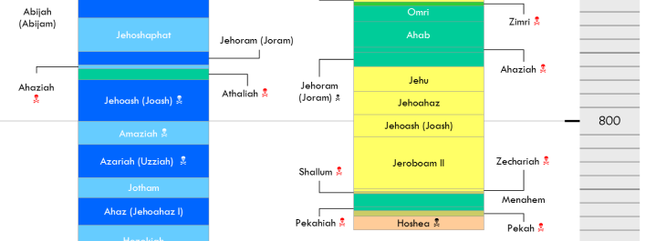

During the reign of Joash in Judah, considered last week, the following happened in Israel:

2 Kings 13:1-7

- How bad had things gotten for Israel under Jehoahaz?

- What did Jehoahaz do to correct this situation?

Note: Two possibilities on the “deliverer”: Possibly (1) the Assyrian king Adad-nirari III, who attacked Aram ca. 800, thus weakening Israel’s persecutor, or (2) Elisha, whose final visit with Jehoash led to three Israelite victories (v. 19). (from the ESV Study Bible).

At the tail end of the reign of Joash in Judah, considered last week, this king began to reign:

2 Kings 13:10-11

- How is Jehoash, king of Israel characterized?

- How surprising is this?

2 Kings 13:14-19

- What seems to be meant by the phrase, “The chariots and horsemen of Israel”?

- Is there anything surprising about the king’s closeness with Elisha at his death?

- Are there any lessons we can take away from this incident?
2 Kings 13:20-21

- Why do you think this brief incident is recorded here?

2 Kings 13:22-23

- This is a rare but important reference to God’s ancient promises in the book of Kings. How was the Lord’s grace to Israel displayed?

- What is meant by “until this day”? How do we apply this statement to the situation today?

2 Kings 13:24-25

- What is the connection between this and the first incident we read about in Jehoash’s reign?

Now we get to Joash’s son, Amaziah. Recall, Joash had been assassinated because people were so angry that he killed Zechariah, his cousin, son of Jehoiada the high priest, his uncle. The account of his life in Chronicles is more complete, so we will turn there:

2 Chronicles 25:1-4

- What is the evaluation of Amaziah’s first official act?

- What precedent did Amaziah have in this behavior?

- We will see that Amaziah, like his father Joash, only does right in the first part of his reign.

2 Chronicles 25:5-16

- Why was it an act of faith for Amaziah to send home the hired troops from Israel?

- Amaziah’s raid had disastrous results:

  - For the future of Israel-Judah relations

  - For the spiritual welfare of Judah

2 Chronicles 25:17-24

- It has been many generations since Israel has found Judah. Since Ahab and Jehoshaphat, they have worked together. Why does it seem that Amaziah decides to attack now?

- This is a good example of seeing a historical event from multiple perspectives. What are the humans thinking, and what is God doing, through this incident?
- Apply the truth that God works through the various motives of people to accomplish his purposes to our situation today.

2 Chronicles 25:25-28

- Five leaders in a row have now been assassinated or had terrible deaths. No king of Judah has laid down in peace for nearly 60 years, since the time of Jehoshaphat. Review the deaths of the following:

  - Jehoram (2 Chronicles 21:18-20) followed the ways of ______________ and murdered his own _______________. Died of a _____________ disease and was mourned by ___________.

  - Ahaziah. Killed by _____________ along with _______________ king of Israel.

  - Athaliah. Killed by Jehoiada the priest in the place where _____________________

  - Joash. Assassinated because he had killed his ___________, Zechariah the prophet.

  - Amaziah ________________________________________.

What comfort do we get from God’s faithfulness during this dark time?

