DOWNFALL! Bible Study XV, JEHU THE DESTROYER
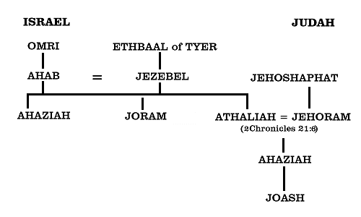
Review:
- What major mistake did Jehoshaphat make, despite being a relatively good king?

- When we last left Joram and Ahaziah, why were they together?

2 Kings 9:1-13

- Did Jehu and his friends seem to take Elisha seriously?

- What do you think accounts for their quick acceptance of the prophet’s message?

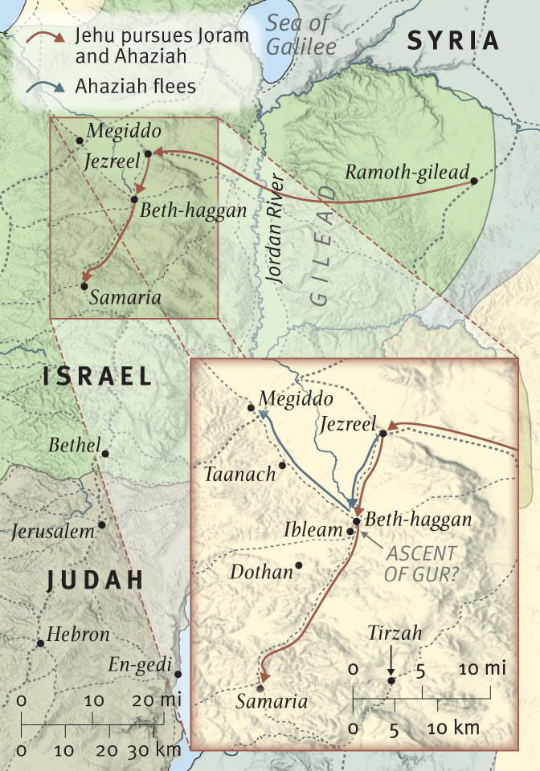
2 Kings 9:14-26

- If this were a movie produced by our church, who would play Jehu and who would play Joram?

- Are these events “fair”? As people who profess the inspiration of scripture, people might criticize us for events like this recorded in the Bible. How do we explain this event, if someone were to ask us about it?

2 Kings 9:27-29

- Why is this a surprise?

- Why would it be fair to say this is the most momentous day in the history of Israel since the days of Solomon and Rehoboam?

2 Kings 9:30-37

- What impression of Jezebel do we get in this brief description?

- What does the behavior of the eunuchs indicate about Jezebel or Jehu?

2 Kings 10:1-17

- List all the people whom Jehu killed.

- See Jeremiah 35 for more information about the descendants of Jehonadab.

2 Kings 10:18-29

- What do you think of Jehu’s ruse?

- So was Jehu a good king? Has he accomplished good?

2 Kings 10:30-36

- What can we take away from our day from Jehu’s commendation by the Lord?

16. Would you agree that “Jehu” would be a good name for a dog?

