DOWNFALL! Bible Study XI, A Depressed Prophet Reassured
Review:
- How did Jezebel threaten Elijah after his triumph at Carmel?
- Where did Elijah first flee, seemingly out of fear or exasperation?
1 Kings 19:9b-18
- Notice that an identical Q&A are found in this section (9b-10, 3b-14).

  - Are Elijah’s concerns valid?

  - God’s appearance between the two questions is reminiscent of God’s appearance to Moses (Ex 33:12-23). What message does this send Elijah?

  - What is the meaning of the fire, wind, etc.?

  - How does the Lord address Elijah’s fears (15-17)?

  - God corrects Elijah’s exaggerated sense of danger (v. 10, 18). When are we likely to exaggerate the danger we face?
Background: Hazael would be the greatest ruler of Aram and dominate Israel. Jehu was the only partially-faithful king of the northern kingdom of Israel. He slaughtered the family of Ahab (after Ahab died) and the king of Judah in one fell swoop. But evaluate this note from the ESV Study Bible:
Interesting interpretive question. Evaluate the following note from the ESV Study Bible:
19:19 he departed from there and found Elisha. Is Elijah back on track as a result of his trip to Mount Horeb? The closing verses of ch. 19 suggest not. There is no mention here or in the upcoming chapters of Elijah’s ever meeting (or trying to meet) Hazael and Jehu. One never reads of Hazael’s being anointed, while it falls to Elisha to arrange the anointing of Jehu (2 Kings 9:1–13). Even Elijah’s response to God’s command about Elisha seems less than wholehearted. There is no mention of his “anointing” of Elisha as his prophetic successor; he merely enlists him as his assistant (1 Kings 19:21). Yet the names of the two prophets indicate the way that God’s plan is nevertheless unfolding. Elijah has all but had his day—the day when it was established that “the Lord, he is God” (18:39), which is what the name “Elijah” means. The new era of salvation belongs to Elisha, whose name means “God saves.”

1 Kings 19:19-21
      - Compare Elisha’s attitude to what we have just seen from Elijah.

      - Compare this account to Luke 9:57-62. How does this shed light on that passage?

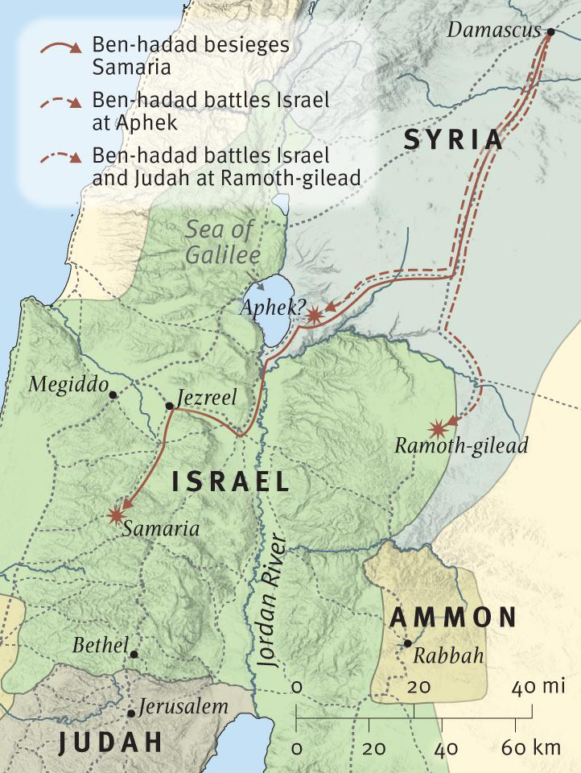
Summary of chapter 20: Ahab’s Wars with Syria
Ahab’s reign was marked by repeated conflict with Ben-hadad of Syria. Ben-hadad’s poor military organization accounted for his failed siege of Samaria, and Ahab defeated him again the next spring at Aphek. Ahab lost his life, however, attempting to retake Ramoth-gilead from Ben-hadad at the eastern edge of his kingdom

Ahab’s War against Syria. After Elijah’s recruitment of Elisha, one expects to read of his anointing of Hazael as king over Syria and of Jehu as king over Israel (cf. 19:15–18). Instead, one finds a story in which a different prophet appears and in which a different king of Syria (Ben-hadad) loses a war with Ahab. The message of ch. 19 is thus underlined: Elijah is not the only servant of God left, in spite of what he has claimed (19:10, 14); and the quiet ways of God must take their course for a while before the events spoken of in 19:17 come to pass.

