DOWNFALL! Bible Study X, A Depressed Prophet
Review:
- How many spectators and how many prophets were assembled on Mt. Carmel?

- What were some things that they did to get their gods’ attention?
1 Kings 18:36-39
- In. vv. 30-35, what ways is Elijah’s sacrifice so different from the prophets of Baal?

- From vv. 36-37, does Elijah seen to know what’s coming?

- In what ways do we see God’s grace highlighted in vv. 38-39 (and this whole section)?

- Agree/Disagree: the punishment for the prophets of Baal was too harsh. See (Deut 13).
1 Kings 18:40-45
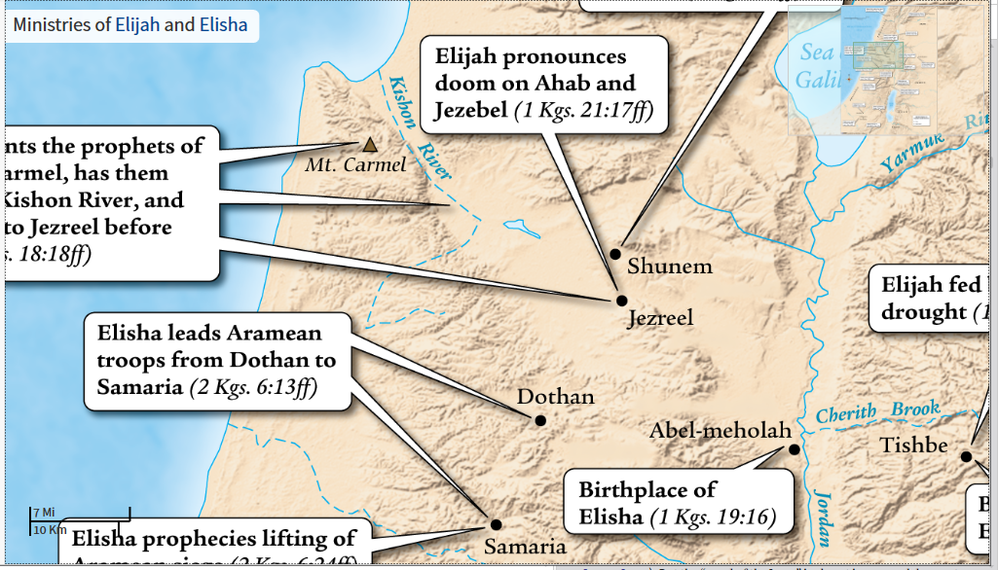
Kishon Valley (18:40). Through this small, narrow valley runs a river draining a very large area to the east. This river swelled during the winter months and flooded the entire region, making passage nearly impossible. This is the reason the prophet urged Ahab to return to Jezreel without delay (18:44). The Kishon figures prominently in the victory of Deborah and Barak over the Canaanites (Judg. 4–5), an event that must have been in the minds of the Israelites and the pagan priests as they witnessed Yahweh’s victory on Mount Carmel.
- What do you think is the significance of the following:

  - Elijah telling Ahab to eat and drink.

  - Elijah’s head between his knees.

  - Checking seven times before seeing a cloud.

  - Elijah running ahead of Ahab.

Evaluation: What do you make of these notes from the Zondervan Illustrated Bible Backgrounds Commentary:
The sky grew black with clouds, the wind rose, a heavy rain came on and Ahab rode off to Jezreel (18:45). Rainfall in the Holy Land typically occurs only when storms push their way across the Mediterranean Sea, usually accompanied by strong winds and dramatic clouds. There is no better location at which to experience these storms than the summit of Mount Carmel. The Canaanites attributed the power of such storms to Baal, as in this passage from the Baal Cycle at Ugarit: “Baal (can) send his rain in due season … shout aloud in the clouds … shoot (his) lightning-bolts to the earth.” Such descriptions of Baal highlight the fact that it was Yahweh who in the end possessed these qualities and broke the three-year drought (see comment on 18:38).
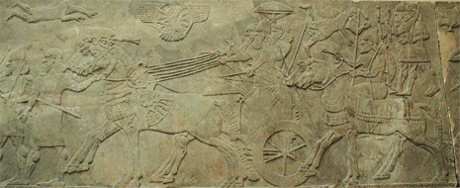
Runners going before the king’s chariot
▲ Michael Greenhalgh/ArtServe, courtesy of the British Museum
He ran ahead of Ahab all the way to Jezreel (18:46). By running ahead of the king’s chariot the prophet may have been symbolically representing Yahweh, the king’s new patron deity. Hittite kings were known to describe their chariots as vehicles led by the gods. Ramesses II of the thirteenth century b.c. noted the advance of the god Montu running before his chariot as he advanced into battle. It is equally likely, however, that Elijah’s position ahead of the chariot was one of respect and allegiance. This precise intent is conveyed in the eighth-century b.c. Bar Rakub inscription, in which a Syrian vassal shows his devotion to Tiglath-pileser III by “running at his wheel” as an outrunner.
Discussion: What do you think Elijah expected to happen next?
1 Kings 19:1-9
- Why was Jezebel’s threat credible (18:4, 13)?

- Beersheba was 120 miles away, about a six day walking journey.

  - What is the significance of:

  - Elijah’s journey into the desert?

  - His wish for death?

  - He comment about the ancestors?
- Did Elijah travel to Beersheba and Horeb at the Lord’s command or on his own initiative?

- How many allusions to Bible stories from earlier in the Old Testament can you find in this section?

- What is the effect of all those allusions?

1 Kings 19:9b-18
- Notice that an identical Q&A are found in this section (9b-10, 3b-14).

  - Are Elijah’s concerns valid?

  - God’s appearance between the two questions is reminiscent of God’s appearance to Moses (Ex 33:12-23). What message does this send Elijah?

  - What is the meaning of the fire, wind, etc.?

  - How does the Lord address Elijah’s fears (15-17)?
Background: Hazael would be the greatest ruler of Aram and dominate Israel. Jehu was the only partially-faithful king of the northern kingdom of Israel. He slaughtered the family of Ahab (after Ahab died) and the king of Judah in one fell swoop. But evaluate this note from the ESV Study Bible:
19:19 he departed from there and found Elisha. Is Elijah back on track as a result of his trip to Mount Horeb? The closing verses of ch. 19 suggest not. There is no mention here or in the upcoming chapters of Elijah’s ever meeting (or trying to meet) Hazael and Jehu. One never reads of Hazael’s being anointed, while it falls to Elisha to arrange the anointing of Jehu (2 Kings 9:1–13). Even Elijah’s response to God’s command about Elisha seems less than wholehearted. There is no mention of his “anointing” of Elisha as his prophetic successor; he merely enlists him as his assistant (1 Kings 19:21). Yet the names of the two prophets indicate the way that God’s plan is nevertheless unfolding. Elijah has all but had his day—the day when it was established that “the Lord, he is God” (18:39), which is what the name “Elijah” means. The new era of salvation belongs to Elisha, whose name means “God saves.”

1 Kings 19:19-21
Compare this account to Luke 9:57-62. How does this shed light on that passage?

