DOWNFALL! Bible Study IX, Baal vs. Yahweh
Review:
- What were the sins of Jeroboam son of Nebat?
- What were some major changes made by King Omri of Israel that improved the position of the northern kingdom?
- What did King Ahab change about their national worship, and why did he do it?
- After the LORD gave Elijah power to hold or send the rain, where did he hide him for about 3 years?
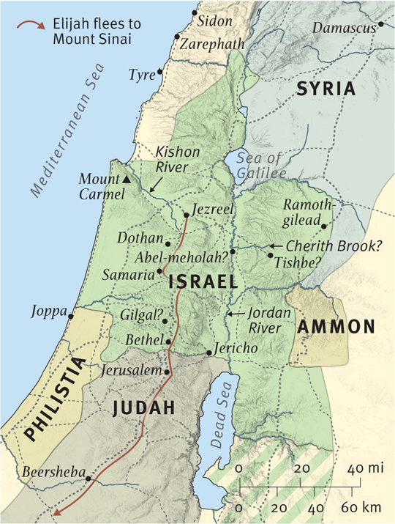
1 Kings 18:1-6
- What were things like in Israel while Elijah was missing?
- The name Obadiah means “servant of Yahweh.” Why is this a fitting name for him?
1 Kings 18:7-15
NOTE: keep the horses and mules alive. Portrays Ahab as a self-centered, calloused ruler scouring his kingdom for what little food and water remain in order to maintain his military strength rather than to ease the suffering of his subjects (cf. 10:26). The annals of the Assyrian ruler Shalmaneser III (ninth century BC) report that Ahab could bring 2,000 chariots against him. NIVSB
- In what way was Obadiah’s fear justified? In what ways was it unjustified?
- When we are afraid of something, we tend to think, “I know as a Christian I’m not supposed to be afraid, BUT…” Correct that kind of thinking.
1 Kings 18:16-18
- This is a short section, but I think worth emphasis. What does Ahab think about Elijah?
- Many of want to make other people happy. We want to have good reputation. What lesson can this teach those of us with such tendencies?
- Read Vv. 19-20. What is the setting of the upcoming contest?
- What picture does v. 21 paint of the people at this time? Can you empathize with them?
- Vv. 22-25 give the ground rules for this contest.
  - How would this demonstrate who was the true God?
  - Can you think of anything in Israel’s history that this would remind them of?
- Vv. 26-29 describe the Baal-ites’ attempt to bring down fire from heaven.
NOTE: 18:24 The god who answers by fire. Fire commonly indicates that God is present (cf. Gen 15:17; Exod 19:18; Hos 8:14; Amos 1:4). Thunderstorms were thought to be chariots on which Yahweh and Baal rode (Ps 104:3; see note on Ps 68:4). Thunder was said to be their voice (see Ps 29:3–9 and note) and lightning (“fire”) their weapons (see Ps 18:14; cf. Lev 9:24). Elijah asks the true God to prove his existence by sending a direct, visible answer.
18:27 taunt. Ridicule familiar beliefs about Baal. deep in thought. Pondering more important things. busy. Perhaps a euphemism for relieving himself. traveling. Out of the “office”; may allude to Baal’s regular descent to the underworld in ritual death. sleeping and must be awakened. May refer to rituals to revive him (cf. v. 28).
18:28 slashed themselves. Self-mutilation, common in ancient mourning rites and possibly a familiar Canaanite cultic gesture; shows a lastditch effort to rouse a lethargic Baal or persuade the death-god Mot to release him. The Mosaic law strictly forbids mutilation of the body (Lev 19:28; Deut 14:1). ZNIVSB

  - Was Elijah’s taunting cruel?
  - Was Elijah’s taunting necessary?
  - Agree/Disagree: It’s not enough to proclaim the true God, we also have to show the futility of people’s idols.
- In. vv. 30-35, what ways is Elijah’s sacrifice so different from the prophets of Baal?
- From vv. 36-37, does Elijah seen to know what’s coming?
  - What is the meaning of “the evening sacrifice in v. 36?
- In what ways do we see God’s grace highlighted in vv. 38-39 (and this whole section)?
- Agree/Disagree: the punishment for the prophets of Baal was too harsh. See (Deut 13).
1 Kings 18:40-45
Kishon Valley (18:40). This valley runs along the eastern edge of Mount Carmel. It drains the entire western half of the Jezreel Valley as far east as Mount Tabor and the outskirts of Tel Jezreel, the winter palace of the Israelite kings. The entire region drains through a narrow break in the ridge connecting Mount Carmel and the ridge on which lie Nazareth and the ancient city of Sepphoris. In antiquity the river swelled during the winter months and flooded the entire region between Megiddo and Nazareth, making passage nearly impossible. This is the reason the prophet urged Ahab to return to Jezreel without delay (18:44). The Kishon figures prominently in the victory of Deborah and Barak over the Canaanites (Judg. 4–5), an event that must have been in the minds of the Israelites and the pagan priests as they witnessed Yahweh’s victory on Mount Carmel.
p 81 Go, eat and drink, for there is the sound of a heavy rain (18:41). The prophet’s provision of food and drink may be a cultural indicator of hospitality and hence also rapprochement between himself and the king. Conversely, social custom suggests that Ahab’s action was one of friendship (see comments on 2:7; 10:4–5). In this time of extended drought, and the undoubted impact on agriculture, eating and drinking was greatly curtailed. Thus, Elijah’s instruction follows logically with the expectation of the end of the drought.
The sky grew black with clouds, the wind rose, a heavy rain came on and Ahab rode off to Jezreel (18:45). Rainfall in the Holy Land typically occurs only when storms push their way across the Mediterranean Sea, usually accompanied by strong winds and dramatic clouds. There is no better location at which to experience these storms than the summit of Mount Carmel. The Canaanites attributed the power of such storms to Baal, as in this passage from the Baal Cycle at Ugarit: “Baal (can) send his rain in due season … shout aloud in the clouds … shoot (his) lightning-bolts to the earth.”³⁴⁴ Such descriptions of Baal highlight the fact that it was Yahweh who in the end possessed these qualities and broke the three-year drought (see comment on 18:38). Ahab most likely followed the high road along the periphery of the valley next to the Carmel range.
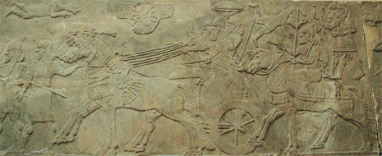
Runners going before the king’s chariot
▲ Michael Greenhalgh/ArtServe, courtesy of the British Museum
He ran ahead of Ahab all the way to Jezreel (18:46). Elijah’s specific action is unclear in the text. It seems that he either accompanied the king as an attendant or raced Ahab to Jezreel by taking a more direct route that the heavy chariot could not attempt. In light of ancient Near Eastern parallels and biblical contexts, the former explanation is more compelling. By running ahead of the king’s chariot the prophet may have been symbolically representing Yahweh, the king’s new patron deity. Hittite kings were known to describe their chariots as vehicles led by the gods. Ramesses II of the thirteenth century b.c. noted the advance of the god Montu running before his chariot as he advanced into battle.
It is equally likely, however, that Elijah’s position ahead of the chariot was one of respect and allegiance. This precise intent is conveyed in the eighth-century b.c. Bar Rakub inscription, in which a Syrian vassal shows his devotion to Tiglath-pileser III by “running at his wheel” as an outrunner.

These notes from the Zondervon Illustrated Bible Backgrounds Commentary

